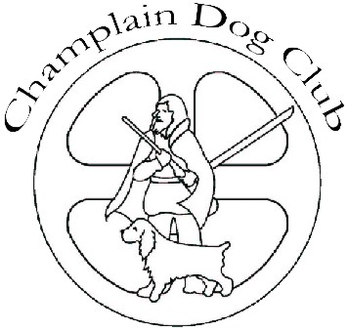

Champlain Dog Club

May 7, 2018

To: Ontario Federation of Anglers and Hunters, Zone E

On behalf of the Champlain Dog Club, we want to thank you for your generous support as a sponsor of our dog show this past April. Once again, it is so wonderful to have you acknowledge and stand behind our annual event in the community.

We have enclosed a picture of 11 year old, Junior Handler and club member, Danika Cooney winning an award with her five year old German Shorthaired Pointer. This dog is a newly crowned Conformation Champion and an active hunter that is working towards an FDJ title (Field Dog Junior). This wonderful team has also achieved German titles, namely an SG Conformation and Derby Prize.

We truly appreciate your past and present support.

Sandra Allen
Champlain Dog Club – President

