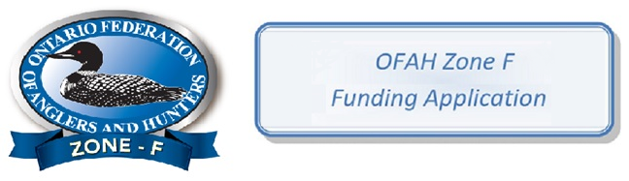

OFAH Zone F Request For Funding (RFF)
NAME OF ORGANIZATION: _______________________________________________________________
CANADA POST MAILING ADDRESS
CONTACT NAME: _____________________________ POSITION: _________________________________
STREET ADDR: _________________________________________________________________________
CITY: ___________________________ POSTAL CODE: _____________________
PHONE: ___________________ EMAIL: _________________________________ FAX: ________________
CHARITABLE REGISTRATION # ____________________________________________________________
OFAH Member? Yes__ No__ Membership number: _______________
Name cheque should be made out to if application is approved: _________________________________
Has your organization applied previously for funding? Yes __ No__ If yes, what year________________
Has your organization previously received funding? Yes__ No__ If yes, what year__________________
Has a request been done with another Zone Yes __ No ___
ELIGIBILITY
Does this project:
1. Conserve or enhance natural habitat. _______
2. Promote, cooperate, or participate in conservation education. __________
3. Promote and support scientific research in the areas of fish and wildlife. ______
4. Promote and enhance the wise use of fish, wildlife and natural resources. _________
5. Cooperate with other organizations in conservation. __________

PROJECT OVERVIEW (please be brief with your answer)
Project title: ___________________________________________________________________________ Project objectives: _____________________________________________________________________________________ __________________________________________________________________________________________________________________________________________________________________________
Project location: ___________________________________________________________________________________
Project duration: Start date ______________________ Completion date: ________________________
Project cost: $ _________________________ Amount of Funding being requested: $ ________________

Grant Application: DETAILS OF PROJECT (Please be as specific as possible with your answer, attaching pages if necessary)
_______________________________________________________________________________________ ________________________________________________________________________________________________________________________________________________________________________________ ________________________________________________________________________________________________________________________________________________________________________________________________________________________________________________________________________________________________________________________________________________________________
Project Funding Partners: (Please list other planed sources of project resources) _____________________________________________________________________________________ ____________________________________________________________________________________________________________________________________________________________________________________________________________________________________________________________________________________________________________________________________________________
How will the OFAH Zone F participation be recognized? _________________________________________ __________________________________________________________________________________________________________________________________________________________________________
As per Canada Revenue Agency (CRA), Organizations not registered as a charity with CRA must provide a report detailing the results of your Program/Event within 30 days of the program/event completion. Failure to do so will result in future funding being denied.
This application form and report, along with copies of receipts, should be sent to: Ben Storey, Zone F Secretary Treasurer, @ ben.storeyofah@gmail.com or to 346 MacPhail's Rd
Perth Ont
K7H 3C8

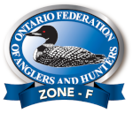

Your Funding Report
Name and date of Project or Event _____________________________________________

Location & Function of Event __________________________________________________

Exactly how was the money you received from OFAH Zone F used to complete the project. _____________________________________
Was the project completed as per the project description on the RFF? and when ______
Primary Contact ____________________________________________________________

Phone or Email _____________________________________________________________

Number of Participants _______________________________________________________

How many volunteers participated in the project? _________________________________
How many participants directly benefitted from the project? ________________
Were there pictures taken? _____________________________________________________

Can we share photos on our website? _____________________

How was Zone F recognized? ________________________________________________

Please submit this report no later than thirty days after the project to, Ben Storey, Zone F Secretary Treasurer,ben_storey@rogers.com or 6 Crofton Road, Nepean, K2G 0M9

