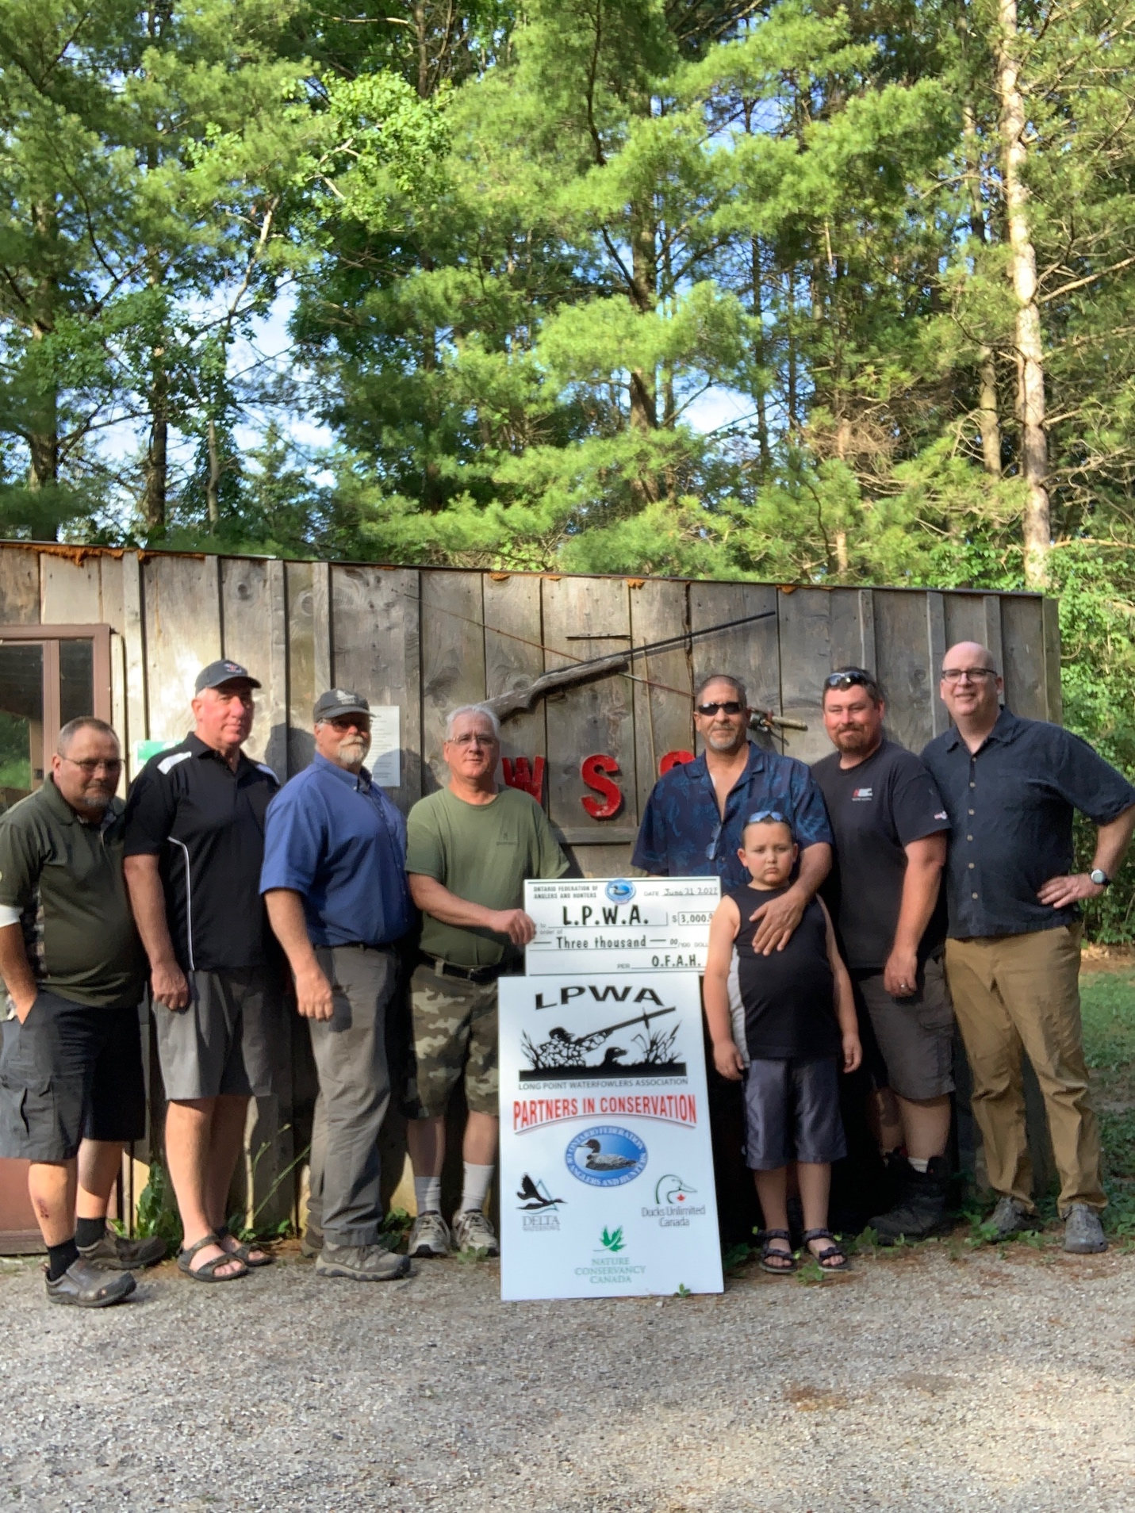

(L-R) Ray Boilard (1st Vice-Chair), Mark Braet (2nd Vice-Chair), Tony Jackson (2nd Past-Chair, Provincial Director at Large), Greg Balch (Chair), John Foster (President, LPWA), Kash Proper, Brian Moore (Past- Chair), Paul Prowse (Treasurer/Secretary).

**Long Point Waterfowlers Association receives a $3000 Grant Cheque from OFAH Zone J.**

Ontario Federation of Anglers and Hunters (OFAH) Zone J Executive presented a $3000 grant to Long Point Waterfowlers Association. LPWA is a long-standing partner and affiliated club within OFAH Zone J.  These funds will help with the Long Point Crown Marsh enhancements that support the sustainable activities associated with and including hunting opportunities.

Receiving the cheque are LPWA President, John Foster, and grandson, Kash Proper.

One of the many benefits to being a Club Member of Ontario Federation of Anglers and Hunters Zone J is the ability to apply for grant funding from the OFAH. Please contact secretaryzonej@gmail.com to request an application.